Yuva Intern – Task 5

Analytics Report & Insights Documentation
Candidate Detail | Information
Candidate Name | UTSAV KANT JHA
Internship Platform | Yuva Intern
Internship Role | Data Analyst
Submission Date | 27/10/2026

1. Executive Summary
Business objective. Help pollution-control and public-health decision makers understand where, when and why air quality is worst across India, so that they can decide where to act first.
Data used. 86,754 daily records from 109 monitoring stations in 21 states, from 1 Jan 2015 to 1 Jul 2020 (no missing values, no duplicates after cleaning).
Major findings
- The average AQI is 176.8 ("Moderate" to "Poor" border). 32.7% of all station-days were Poor or worse, and 19.5% were Very Poor or Severe.
- Pollution is strongly seasonal: Winter (AQI 239) and Post-Monsoon (231) are about 2.1 times worse than Monsoon (114). November–December average 259, while August averages 102.
- The north Indian belt is the hotspot: Delhi (DL) 235, Uttar Pradesh 216, Bihar 215 and Haryana 210, against Karnataka 92 and Kerala 80.
- PM2.5 is the main driver: correlation with AQI is 0.86, the highest of all pollutants (PM10 is 0.73).
- During the 2020 lockdown months, AQI on the same 99 stations fell 28% (Jan–Jun 2019: 191 → 2020: 137), and by 47% in April alone.
Key metrics: Avg AQI 176.8 | Median AQI 133 | Avg PM2.5 79.0 µg/m³ | Poor-or-worse days 32.7% | Very Poor/Severe days 19.5%.
Conclusion. Air-quality risk is concentrated in a few northern states and in October–February. Targeted, season-specific action on particulate matter (PM2.5 and PM10) will give the biggest benefit.
Top recommendations: (1) start winter action plans in October in DL, UP, BR, HR; (2) focus on PM2.5/PM10 sources; (3) issue health alerts on Very Poor days; (4) improve monitoring coverage in states with only one station.

2. Business Objectives (Step 1)

2.1 What this step means
Before touching the data, we write down the business problem, the questions to be answered and who will read the report. This keeps the analysis focused. Without it, a report is only a collection of random charts.

2.2 Business problem
Air pollution affects health, productivity and healthcare cost. Decision makers have limited budgets, so they must know which states, which months and which pollutants need attention first.

2.3 Stakeholders
Stakeholder | What they need
State Pollution Control Boards / CPCB | Which states and seasons need action
Health Department | When to issue health alerts
Urban Planning Team | Which pollutants to control (traffic, dust, industry)

2.4 Key business questions
- How good or bad is air quality overall? (Example answer: 32.7% of days are Poor or worse.)
- Which states and stations are most polluted? (Example answer: Delhi, UP, Bihar, Haryana.)
- How does pollution change by season and month? (Example answer: Nov–Dec are the worst months.)
- Which pollutant drives the AQI? (Example answer: PM2.5.)
- Is air quality improving over time, and what did the 2020 lockdown change?

2.5 Success metrics (KPIs)
Average AQI, % of Poor-or-worse days, average PM2.5, and seasonal/state AQI difference.
Example of how an AQI bucket is defined (from the data): Good 0–50, Satisfactory 51–100, Moderate 101–200, Poor 201–300, Very Poor 301–400, Severe 401–500.

3. Data Overview and Preparation

3.1 About the dataset
The file station_day_clean.csv has 86,754 rows and 19 columns. Each row is one monitoring station on one day.
Column group | Columns | Example value
Identifiers | StationId, State | AP001, AP
Date fields | Date, Year, Month, Season | 25-11-2017, 2017, 11, Post-Monsoon
Pollutants | PM2.5, PM10, NO, NO2, NOx, NH3, CO, SO2, O3, Benzene, Toluene | PM2.5 = 81.40
Air-quality result | AQI, AQI_Bucket | 184, Moderate

3.2 Cleaning already done (Task 4)
The original station_day.csv had many missing pollutant values. In Task 4 these were handled and the clean file was saved. Result: 0 missing values and 0 duplicate rows. (Add 2–3 lines here from your own Task 4 notebook: how many missing values were there and how you filled them, for example with median or forward-fill.)

Code Block 1 – Import libraries and load data
Purpose: Load the file and convert Date from text to a real date so we can sort and group by time. Example: 25-11-2017 (text) becomes 2017-11-25 (date).
import pandas as pd
import numpy as np
import matplotlib.pyplot as plt
import seaborn as sns
import warnings
warnings.filterwarnings('ignore')
sns.set_theme(style='whitegrid')
plt.rcParams['figure.figsize'] = (10, 5)
df = pd.read_csv('station_day_clean.csv')
df['Date'] = pd.to_datetime(df['Date'], format='%d-%m-%Y')
print(df.shape)
df.head()
Output:
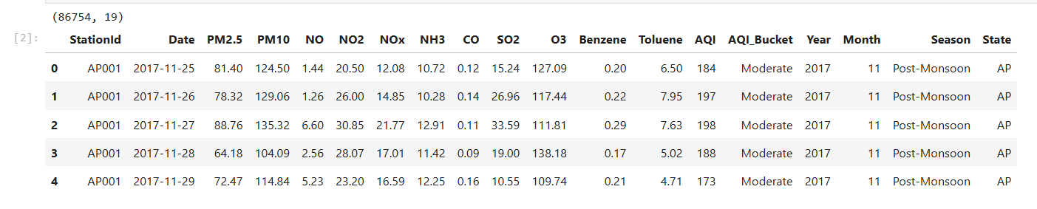
Expected output: (86754, 19) and the first 5 rows (station AP001, Nov 2017).

Code Block 2 – Data quality check
Purpose: Confirm the data is trustworthy before analysis. Wrong data means wrong decisions.
print('Missing values :', df.isnull().sum().sum())
print('Duplicate rows :', df.duplicated().sum())
print('Date range :', df['Date'].min().date(), 'to', df['Date'].max().date())
print('Stations :', df['StationId'].nunique())
print('States :', df['State'].nunique())
df.describe().T.round(2)
Output:
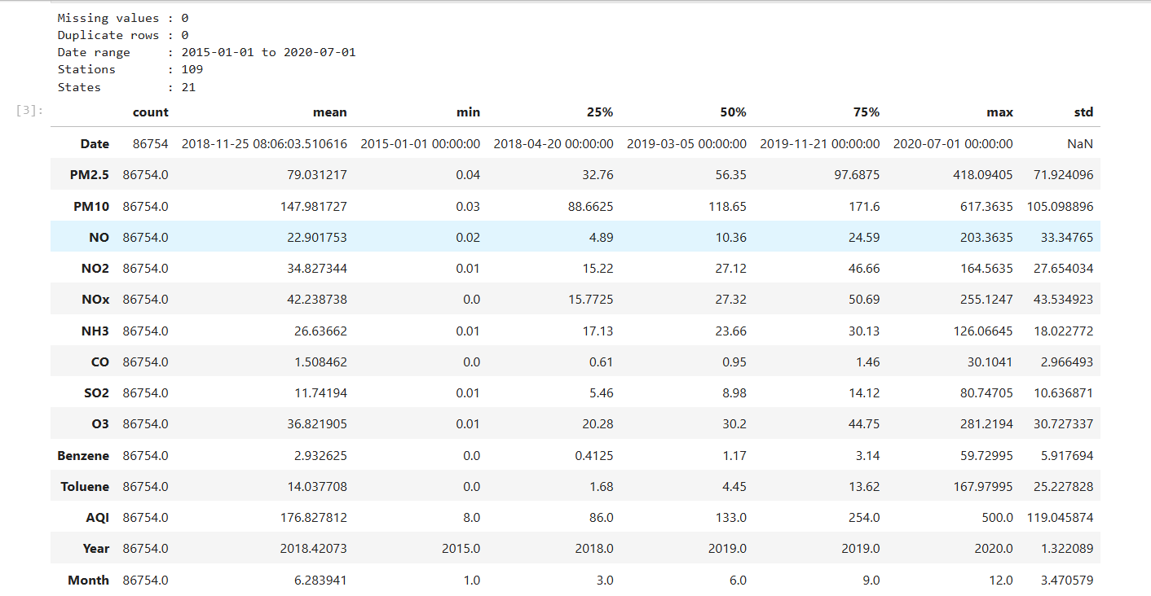
Expected output and how to read it: 0 missing, 0 duplicates, 2015-01-01 to 2020-07-01, 109 stations, 21 states. In describe(), mean PM2.5 is 79.0 and the maximum AQI is 500 (the scale limit).
Data limitations (important to mention in the report):
- Delhi supplies 41.5% of all rows (36,010 records), so overall averages lean towards Delhi.
- Station coverage grew from 21 stations in 2015 to 107 in 2020, so year-to-year comparisons must be done carefully.
- 2020 has data only up to 1 July.
- Some states have just one station (for example Gujarat: GJ001), so a state average may represent one location only.

4. Analysis and Findings (Step 2)

4.1 What this step means
Here we calculate numbers to answer the key questions: trends, patterns, relationships, performance indicators and problem areas. Every finding must have a number.

Code Block 3 – Key Performance Indicators (KPIs)
Purpose: One small table that tells the whole story in 7 numbers. Example: If 32.7% of days are Poor or worse, then roughly 1 day in 3 has unhealthy air.
poor_days = df['AQI_Bucket'].isin(['Poor', 'Very Poor', 'Severe'])
vp_days = df['AQI_Bucket'].isin(['Very Poor', 'Severe'])
kpi = pd.DataFrame({
'KPI': ['Total station-day records', 'Monitoring stations', 'Average AQI',
'Median AQI', 'Average PM2.5 (ug/m3)', '% days Poor or worse',
'% days Very Poor or Severe'],
'Value': [f"{len(df):,}", df['StationId'].nunique(), round(df['AQI'].mean(), 1),
df['AQI'].median(), round(df['PM2.5'].mean(), 1),
round(poor_days.mean() * 100, 1), round(vp_days.mean() * 100, 1)]
})
kpi
Output:
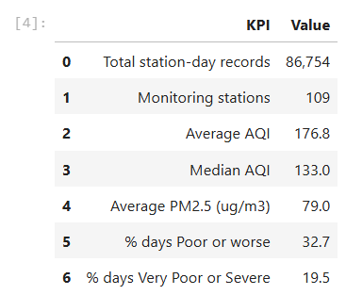
Expected output: 86,754 | 109 | 176.8 | 133.0 | 79.0 | 32.7 | 19.5. Finding: The average AQI (176.8) is much higher than the median (133). This means a small number of very polluted days pull the average up, so the "bad days" are the real problem.

Code Block 4 – State-wise analysis
Purpose: Find which states are the most polluted. Example: Delhi has an average AQI of 235 and 53.7% of its days are Poor or worse.
state_tbl = df.groupby('State').agg(
avg_aqi=('AQI', 'mean'),
avg_pm25=('PM2.5', 'mean'),
stations=('StationId', 'nunique'),
records=('AQI', 'size')
).round(1)
state_tbl['pct_poor_or_worse'] = (
df.assign(p=poor_days).groupby('State')['p'].mean() * 100
).round(1)
state_tbl = state_tbl.sort_values('avg_aqi', ascending=False)
# Use only states with 2+ stations for a fair ranking
reliable = state_tbl[state_tbl['stations'] >= 2]
print('Top 5 states:'); print(reliable.head(5))
print('Cleanest 5 states:'); print(reliable.tail(5))
Output:
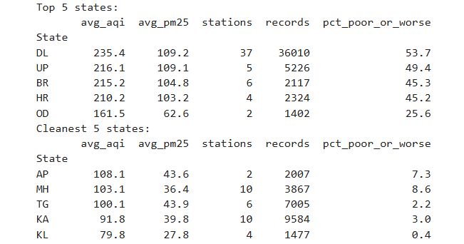
Expected output (top 5): DL 235.4, UP 216.1, BR 215.2, HR 210.2, OD 161.5. Cleanest: KL 79.8, KA 91.8, TG 100.1, MH 103.1, AP 108.1. Finding: Delhi, UP, Bihar and Haryana average above 210, which is more than double Kerala. Gujarat shows 356 but has only one station (GJ001), so it is excluded from the fair ranking and flagged for follow-up.

Code Block 5 – Seasonal and monthly analysis
Purpose: Find when pollution is worst. Example: Winter AQI 239.2 divided by Monsoon AQI 114.0 = 2.1, so winter is 2.1 times worse.
season_order = ['Winter', 'Summer', 'Monsoon', 'Post-Monsoon']
season_tbl = df.groupby('Season')[['AQI', 'PM2.5', 'PM10']].mean().round(1).loc[season_order]
print(season_tbl)
print('Winter / Monsoon ratio:', round(season_tbl.loc['Winter', 'AQI'] / season_tbl.loc['Monsoon', 'AQI'], 1))
month_tbl = df.groupby('Month')[['AQI', 'PM2.5']].mean().round(1)
month_tbl
Output:
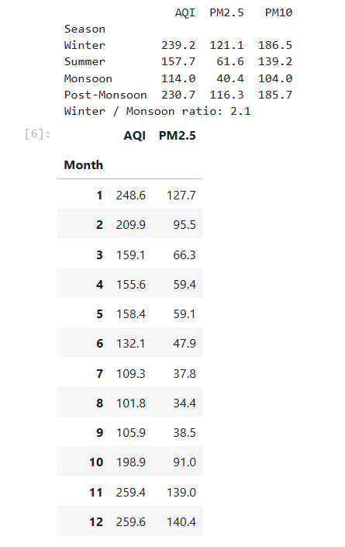
Expected output: Winter 239.2, Summer 157.7, Monsoon 114.0, Post-Monsoon 230.7, ratio 2.1. Monthly AQI is lowest in August (101.8) and highest in December (259.6); November is 259.4. Finding: Pollution rises sharply from October (198.9) to November (259.4), a jump of about 30% in one month.

Code Block 6 – Pollutant relationship (correlation)
Purpose: Find which pollutant moves together with AQI. Example: A correlation of 0.86 means that when PM2.5 goes up, AQI almost always goes up too (1.0 = perfect match, 0 = no relation).
pollutants = ['PM2.5', 'PM10', 'NO', 'NO2', 'NOx', 'NH3', 'CO', 'SO2', 'O3', 'Benzene', 'Toluene', 'AQI']
corr = df[pollutants].corr()
corr['AQI'].drop('AQI').sort_values(ascending=False).round(2)

Output:
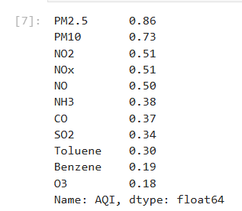
Expected output: PM2.5 0.86, PM10 0.73, NO2 0.51, NOx 0.51, NO 0.50, NH3 0.38, CO 0.37, SO2 0.34, Toluene 0.30, Benzene 0.19, O3 0.18. Finding: PM2.5 and PM10 (fine and coarse dust particles) are the strongest drivers of AQI. Gases such as CO and SO2 matter much less.

Code Block 7 – Time trend and lockdown effect
Purpose: See whether air quality is improving and what happened during the 2020 lockdown. Example: April 2019 average AQI was 175.5 and April 2020 was 93.9, so the change is (93.9 / 175.5 − 1) × 100 = −46.5%.
# Yearly trend (note: number of stations grows every year)
year_tbl = df.groupby('Year').agg(avg_aqi=('AQI', 'mean'), stations=('StationId', 'nunique')).round(1)
print(year_tbl)
# Delhi only - fairer long-term view
delhi_year = df[df['State'] == 'DL'].groupby('Year')['AQI'].mean().round(1)
print(delhi_year)
# Lockdown: compare Jan-Jun 2019 vs 2020 on the SAME stations only
common = set(df[df['Year'] == 2019]['StationId']) & set(df[df['Year'] == 2020]['StationId'])
cmp = df[df['StationId'].isin(common) & df['Year'].isin([2019, 2020]) & (df['Month'] <= 6)]
res = cmp.groupby('Year')['AQI'].mean().round(1)
print('Stations compared:', len(common))
print(res)
print('Overall change %:', round((res[2020] / res[2019] - 1) * 100, 1))
mm = cmp.pivot_table(index='Month', columns='Year', values='AQI').round(1)
mm['change_%'] = ((mm[2020] / mm[2019] - 1) * 100).round(1)
mm

Output:
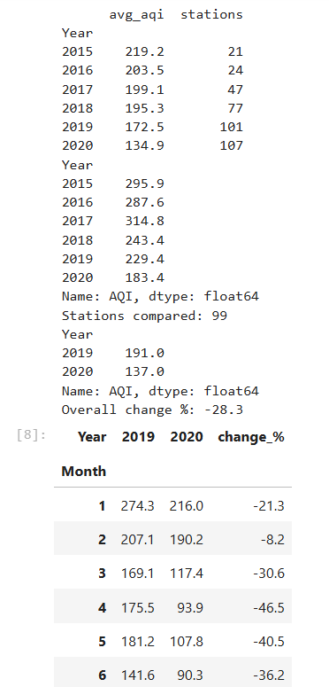

Expected output: Overall AQI falls from 219.2 (2015) to 172.5 (2019) and 134.9 (2020). Delhi falls from 295.9 (2015) to 229.4 (2019). On 99 common stations, Jan–Jun AQI goes from 191.0 (2019) to 137.0 (2020), which is −28.3%. Monthly change: March −30.6%, April −46.5%, May −40.5%, June −36.2%. Finding: Air quality improved gradually until 2019. The all-India figure should be read with care because station count grew from 21 to 101, which is why the Delhi-only line and the same-station lockdown comparison are used.

Code Block 8 – Most and least polluted stations
Purpose: Identify exact locations that need attention.
station_avg = df.groupby('StationId')['AQI'].mean().sort_values(ascending=False).round(1)
print('Most polluted stations:'); print(station_avg.head(5))
print('Cleanest stations:'); print(station_avg.tail(5))
Output:
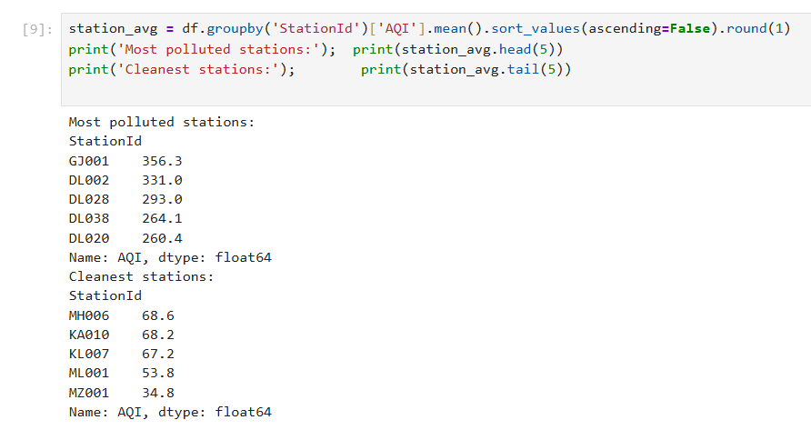

Expected output: Worst: GJ001 356.3, DL002 331.0, DL028 293.0, DL038 264.1, DL020 260.4. Cleanest: MZ001 34.8, ML001 53.8, KL007 67.2, KA010 68.2, MH006 68.6. Finding: Four of the five worst stations are in Delhi; the cleanest are in the north-east and south.

5. Visualizations (Step 3)

5.1 What this step means
Charts let a manager understand in seconds what a table needs minutes to explain. Every chart needs a title, labelled axes and one line of meaning below it. Below, each chart answers one business question.

Code Block 9 – Chart 1: Top 10 most polluted states
Question answered: Where is the problem largest?
top10 = reliable.head(10).reset_index()
plt.figure()
sns.barplot(data=top10, x='avg_aqi', y='State', palette='Reds_r')
plt.title('Top 10 Most Polluted States (Average AQI, states with 2+ stations)')
plt.xlabel('Average AQI')
plt.ylabel('State')
plt.tight_layout()
plt.savefig('chart1_states.png', dpi=150)
plt.show()
Output:
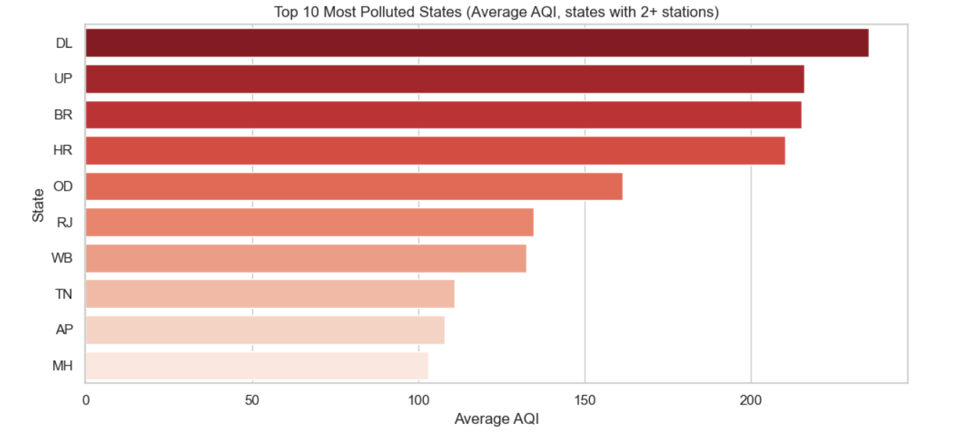
Insight line: Delhi, UP, Bihar and Haryana lead with AQI above 210.

Code Block 10 – Chart 2: Average AQI by season
Question answered: Which season is most dangerous?
plt.figure()
ax = sns.barplot(x=season_tbl.index, y=season_tbl['AQI'], palette='coolwarm')
ax.bar_label(ax.containers[0], fmt='%.0f')
plt.title('Average AQI by Season')
plt.xlabel('Season')
plt.ylabel('Average AQI')
plt.tight_layout()
plt.savefig('chart2_season.png', dpi=150)
plt.show()
Output:
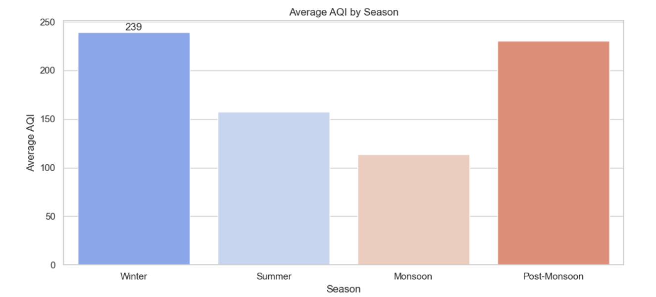
Insight line: Winter (239) and Post-Monsoon (231) are about twice as bad as Monsoon (114).

Code Block 11 – Chart 3: Monthly trend of AQI and PM2.5
Question answered: In which exact months should action start?
fig, ax1 = plt.subplots()
ax1.plot(month_tbl.index, month_tbl['AQI'], marker='o', color='navy', label='AQI')
ax1.set_xlabel('Month (1 = Jan, 12 = Dec)')
ax1.set_ylabel('Average AQI', color='navy')
ax1.set_xticks(range(1, 13))
ax2 = ax1.twinx()
ax2.plot(month_tbl.index, month_tbl['PM2.5'], marker='s', color='red', label='PM2.5')
ax2.set_ylabel('Average PM2.5 (ug/m3)', color='red')
plt.title('Monthly Average AQI and PM2.5')
fig.tight_layout()
plt.savefig('chart3_monthly.png', dpi=150)
plt.show()
Output:
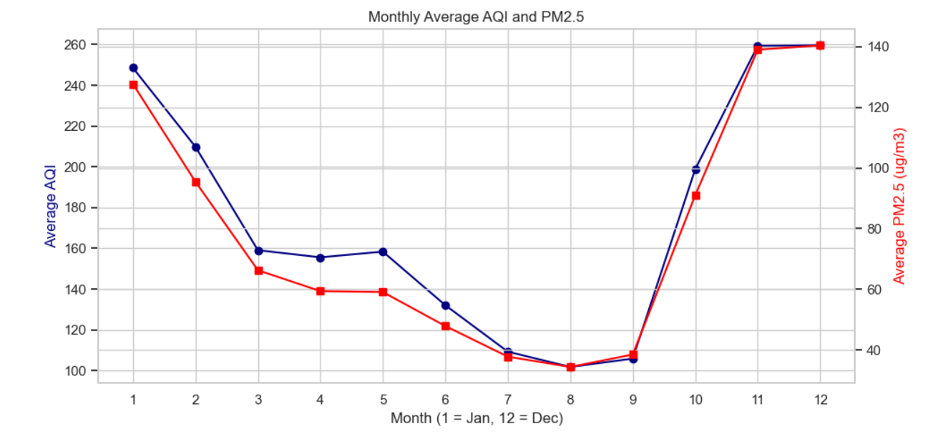
Insight line: The curve is U-shaped: high in Nov–Jan, lowest in Jul–Sep. AQI and PM2.5 move together.

Code Block 12 – Chart 4: AQI category distribution
Question answered: How often is air unhealthy?
order = ['Good', 'Satisfactory', 'Moderate', 'Poor', 'Very Poor', 'Severe']
pct = df['AQI_Bucket'].value_counts(normalize=True).reindex(order) * 100
plt.figure()
ax = sns.barplot(x=pct.index, y=pct.values, palette='RdYlGn_r')
for c in ax.containers:
ax.bar_label(c, fmt='%.1f%%')
plt.title('Share of Station-Days by AQI Category')
plt.xlabel('AQI Category')
plt.ylabel('% of days')
plt.tight_layout()
plt.savefig('chart4_buckets.png', dpi=150)
plt.show()
Output:
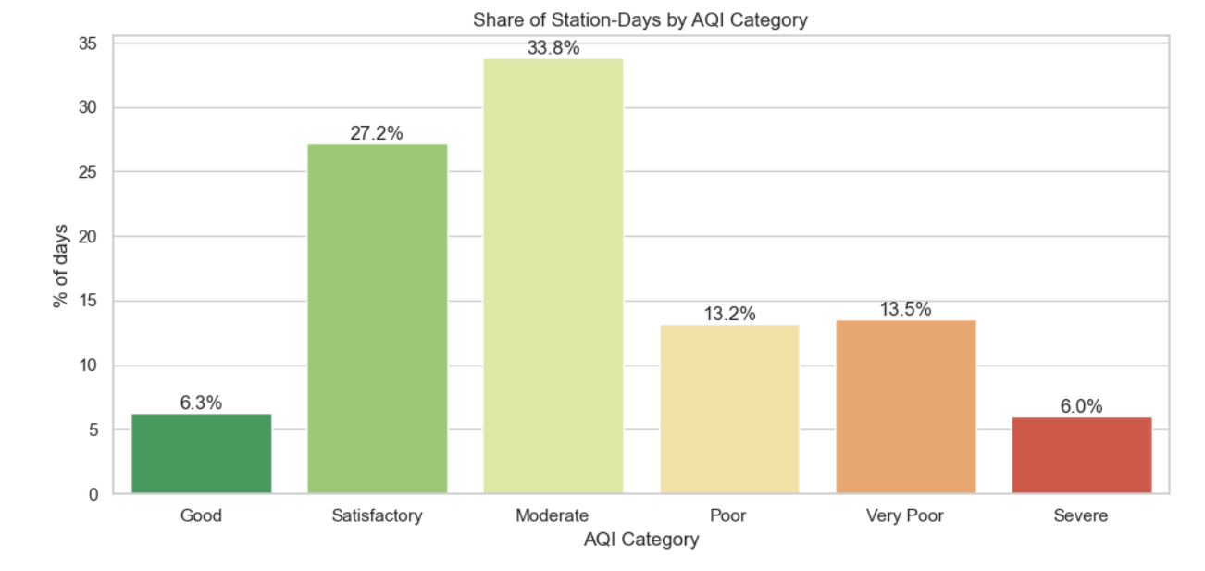
Insight line: Only 6.3% of days are Good; 32.7% are Poor or worse.

Code Block 13 – Chart 5: Correlation heatmap
Question answered: Which pollutants are related to each other and to AQI?
plt.figure(figsize=(10, 8))
sns.heatmap(corr, annot=True, fmt='.2f', cmap='YlOrRd’, center=0)
plt.title('Correlation Between Pollutants and AQI')
plt.tight_layout()
plt.savefig('chart5_corr.png', dpi=150)
plt.show()
Output:
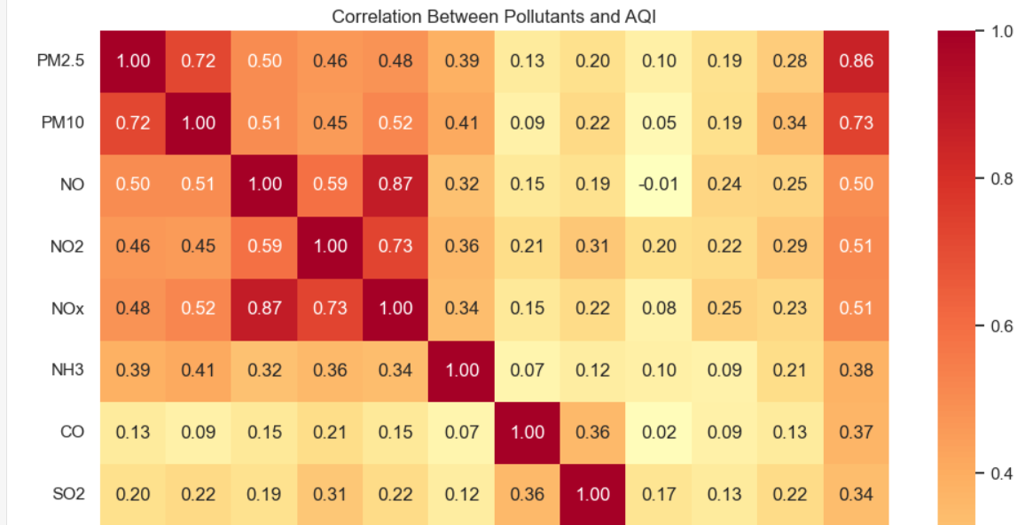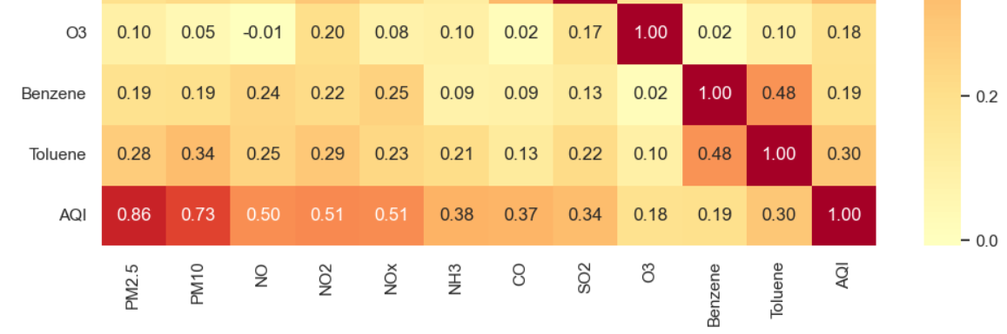
Insight line: PM2.5 and PM10 have a strong link (0.72) and both drive AQI; NO, NO2 and NOx move together, which points to traffic and combustion sources.

Code Block 14 – Chart 6: Season vs AQI category heatmap
Question answered: In which season do the worst categories appear?
ct = (pd.crosstab(df['Season'], df['AQI_Bucket'], normalize='index') * 100).round(1)
ct = ct[order].loc[season_order]
plt.figure()
sns.heatmap(ct, annot=True, fmt='.1f', cmap='YlOrRd')
plt.title('% of Days in Each AQI Category, by Season')
plt.xlabel('AQI Category')
plt.ylabel('Season')
plt.tight_layout()
plt.savefig('chart6_season_bucket.png', dpi=150)
plt.show()

Output:
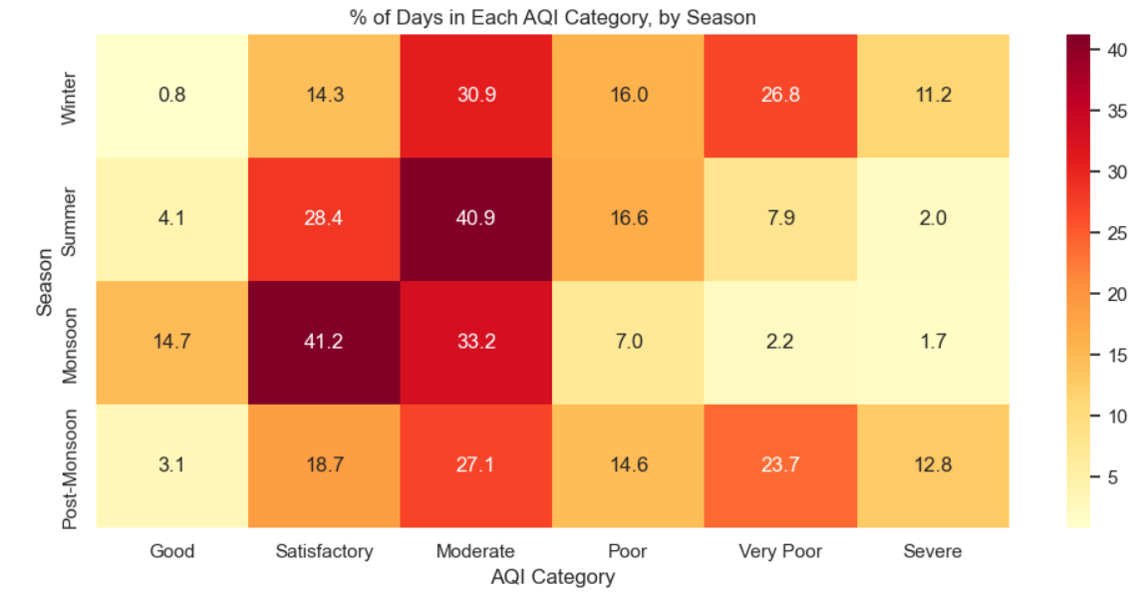
Insight line: In Winter, 26.8% of days are Very Poor and 11.2% Severe (38% together); in Monsoon only 3.9%.

Code Block 15 – Chart 7: Yearly trend (All stations vs Delhi)
Question answered: Is the situation improving?
plt.figure()
plt.plot(year_tbl.index, year_tbl['avg_aqi'], marker='o', label='All stations')
plt.plot(delhi_year.index, delhi_year.values, marker='s', label='Delhi only')
plt.title('Yearly Average AQI: All Stations vs Delhi (2020 = Jan to Jul only)')
plt.xlabel('Year')
plt.ylabel('Average AQI')
plt.legend()
plt.tight_layout()
plt.savefig('chart7_yearly.png', dpi=150)
plt.show()
Output:
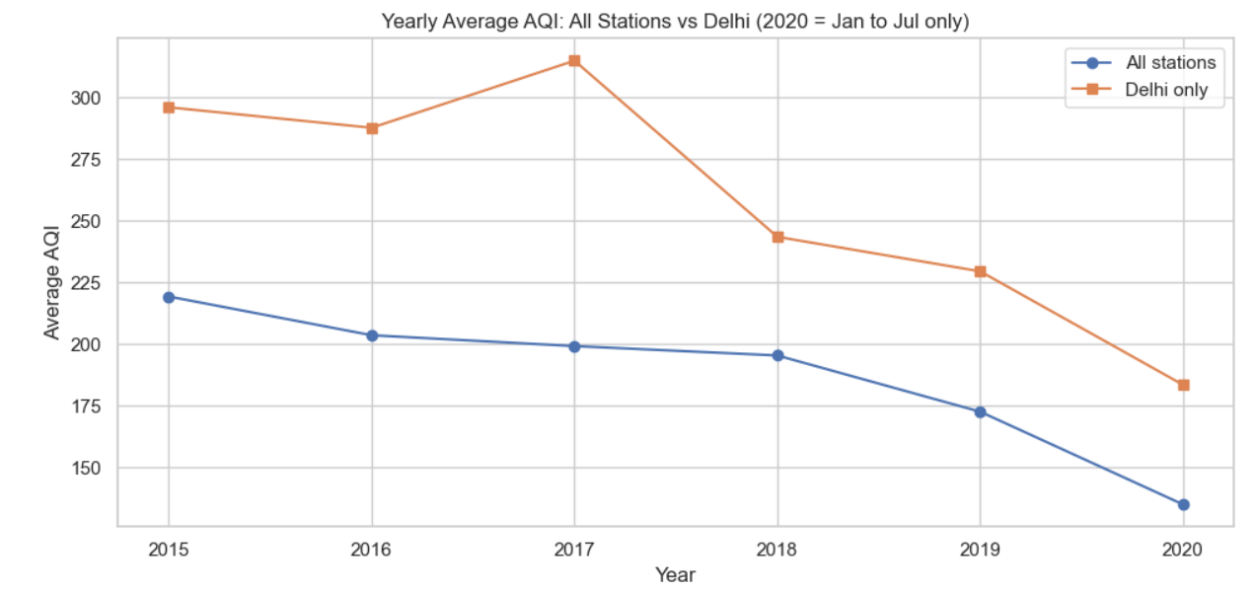
Insight line: “Overall AQI falls steadily. Delhi peaked in 2017 (315) and then dropped to 229 by 2019 and 183 in 2020.”

6. Business Insights (Step 4)

6.1 What this step means
A finding says what the data shows. An insight explains what it means, why it may be happening, and the business impact. Each row below follows this pattern.
# | Finding (What) | Possible reason (Why) | Business impact (So what)
1 | Winter AQI 239 and Post-Monsoon 231 vs Monsoon 114 (2.1×). Nov–Dec ≈ 259, Aug ≈ 102. | Rain washes particles from the air in Monsoon; in cold months air stays still and pollutants are trapped near the ground. Post-monsoon crop-residue burning is also commonly linked to the October–November rise. | Health risk and hospital load peak in Oct–Feb, so budgets and alerts must be timed for these months.
2 | DL 235, UP 216, BR 215, HR 210 vs KA 92, KL 80. | Dense population, heavy traffic, construction dust and industry in the north Indian plains; sea-facing southern states get better air flow. | Four states need priority funding; the cleaner states can be used as benchmarks.
3 | PM2.5 has 0.86 correlation with AQI (PM10 0.73); Delhi's average PM2.5 is 109 µg/m³ vs Karnataka's 40. | AQI is decided mainly by the worst pollutant, and fine dust is usually the worst one. | Controlling dust and fine-particle sources gives more AQI improvement than controlling gases like SO2 or CO.
4 | 32.7% of days are Poor or worse; 19.5% Very Poor or Severe. | Combination of the seasonal and regional hotspots above. | Roughly 1 day in 3 is unhealthy and 1 day in 5 is dangerous for sensitive groups such as children and elderly.
5 | Same-station AQI fell 28% in Jan–Jun 2020 (−47% in April). | Lockdown reduced traffic and industrial activity. | Shows that pollution is strongly linked to human activity and that emission cuts can quickly improve air.
6 | 4 of the 5 worst stations are in Delhi; Gujarat's single station averages 356. | Local hotspots such as traffic junctions and industrial areas. | Station-level action plans are needed; Gujarat needs more monitoring to confirm the picture.
Note on causes: the dataset has no weather, traffic or fire data, so the "possible reasons" above are widely reported explanations, not proof from this data. Recommendation 7 suggests adding such data.

7. Actionable Recommendations (Step 6)

7.1 What this step means
Recommendations turn insights into actions. Each one must say what to do, how important it is, which finding supports it, and the next step.
# | Recommendation | Priority | Supported by | Next step
1 | Start the winter action plan (dust control, burning control, traffic measures) in October, not November, in DL, UP, BR and HR. | High | AQI jumps from 199 (Oct) to 259 (Nov). | Define the plan and the trigger date with the state boards by September.
2 | Make PM2.5 and PM10 the main target of pollution-control spending (road dust, construction, biomass and vehicle emissions). | High | PM2.5 correlation 0.86; PM10 0.73. | Run a source-apportionment study in the top 4 states.
3 | Issue public-health alerts and school/outdoor-activity advisories when AQI is forecast Very Poor or Severe. | High | 19.5% of days are Very Poor or Severe; 38% in Winter. | Connect daily AQI data to an SMS/app alert system.
4 | Test targeted traffic and industrial emission curbs on high-pollution days and measure the result. | Medium | Lockdown cut AQI by 28% (47% in April). | Pilot in Delhi for one winter and compare with the previous year.
5 | Add monitoring stations in states that have only one station (for example GJ, MP, AS, PB). | Medium | Gujarat shows 356 from a single station; coverage grew 21 → 107 stations. | Prepare a station-expansion list and budget.
6 | Study and share practices of low-AQI states (Kerala, Karnataka) as benchmarks. | Low | KL 80, KA 92 against DL 235. | Collect their policies for a comparison note.
7 | Improve future reports by adding weather, traffic and crop-burning data and building a simple AQI forecasting model. | Low | Causes in this report are not proven by the dataset. | Collect the extra data sources for the next analysis cycle.

7.2 Overall conclusion
India's air-quality problem is not uniform: it is concentrated in the north, in the October–February window, and in fine particulate matter. Focusing effort on these three areas will deliver the greatest health and economic benefit for the least spending.

